**EVACUATION SIGN and DIAGRAM**

**Premises Name**

**R**

**EMOVE PEOPLE**

**to the**

**ASSEMBLY AREA**

**A**

**LERT THE FIRE SERVICE**

* **break manual call point**

**C**

**ONFINE FIRE & SMOKE**

**close doors and windows**

**E**

**from immediate danger**

**IN CASE OF FIRE**

**(if safe to do so)**

* **call 000**

**VACUATE**

hose_reelmcpfipfipmcphose_reel

**YOU ARE HERE**

AA

AA

EXIT

ASSEMBLY AREA

PATH OF EXIT

ALTERNATE PATH

FIRE HOSE REEL

EXTINGUISHER

MANUAL CALL POINT

FIRE INDICATOR PANEL

MANUAL CALL POINT

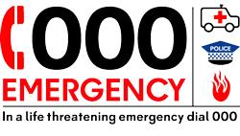

**In an emergency dial 000**

**Mobility impaired persons**

**should evacuate**

**immediately on hearing**

**the fire alarm assisted**

**by a nominated person.**

