EVACUATION SIGN and DIAGRAM
Premises Name

R
EMOVE PEOPLE

to the
ASSEMBLY AREA
A

LERT THE FIRE SERVICE

- break manual call point

C

ONFINE FIRE & SMOKE

close doors and windows
E

from immediate danger

IN CASE OF FIRE
(if safe to do so)
- call 000
VACUATE


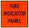
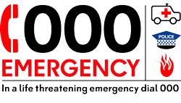
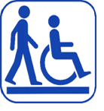

YOU ARE HERE
AA
AA
EXIT
ASSEMBLY AREA

PATH OF EXIT
ALTERNATE PATH
FIRE HOSE REEL
EXTINGUISHER
MANUAL CALL POINT
FIRE INDICATOR PANEL
MANUAL CALL POINT

In an emergency dial 000
Mobility impaired persons
should evacuate
immediately on hearing
the fire alarm assisted
by a nominated person.

